

For this self-study you are going to do a short exercise creating a User-Defined Function that reads data from a steam table and does some simple calculations based on the values read. Unlike previous self-study tasks there are not step by step instructions, just a set of requirements your UDF meet. This is how your coursework will be structured.

Download test_steam.m and SteamTable.csv from the VLE to your local working directory. The test_steam.m program will test your user-defined function for a single set of variables. Scriptcheck will use a wide range of values for the input arguments.

**Background**

A steam table shows the properties of steam at various pressures and temperatures. The far left of the table shows the properties at different pressures as a saturated liquid on the left *(f)* and saturated vapor on the right *(g). v* is the specific volume, *u* is specific internal energy, *h* is specific enthalpy and *s* is specific entropy. Figure 1 shows where this information is located on actual steam table.

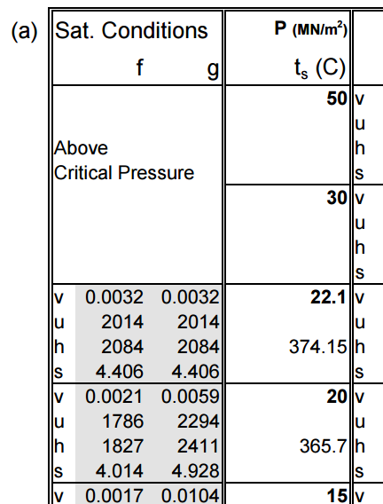

*P*

*vg*

*vf*

Figure 1. Section of the Steam Table with the areas of interest highlighted.

As such the overall specific volume of a fluid is given by:

$$v=x{*v}_{g}+\left(1-x\right)*v_{f}$$

where Steam quality, *x* denotes the ratio of mass of vapor to overall mass of water in the fluid. Density is 1/v.

**Objectives**

This exercise should allow you to demonstrate the following skills:

* File I/O
* Indexing
* Functions
* Using MATLAB to do basic mathematics

**Requirements**

Your task is to write a user-defined function to find the density of steam of various qualities at set pressures stated on the steam table provided. You should read in the data from the file and should search the appropriate column of the data for the appropriate pressure, P. Once the row index of that pressure has been found your code should read off the corresponding values for *vf* and *vg*. From those values you should calculate the specific volume using the equation above, and then find the density.

The program should output a density of -1 if an invalid input is given such as an unlisted pressure or a steam quality outside the range of 0 to 1. 100% will not be achievable if you do not check for these two potential outcomes. Nothing should be outputted to the command window.

The function definition should be ***exactly*** as follows and should go at the start of your m-file (do not change the names of the input or output arguments):

function density=findDensity(steamTableFilename, delimiter, pressure, steamQuality)

*steamTableFilename* will pass the name of the file that holds the steam table information (the file SteamTable.csv can be found on the VLE, download it and see how it is structured, the table corresponds to the one given in Thermofluids 1). *delimiter* will pass the delimiter used in the file. In this example a .csv file is used but we may want to use other delimiters (such as tab) in the future. *pressure* and *steamQuality* have their usual meanings. Use these variables in your code.

You can quickly check your code by typing test_steam in the Command Window. This will undertake a single test on your function for a *pressure* of 20 and *steam quality* of 0.5. Type help test_steam for info. When you’ve passed this test, go on to ScriptCheck below.

***Hints***  
The ***find*** function may be useful in this application (see QG section 6). ***find*** can take a comparison statement, such as A<B, to return the index or array of indices where the statement is satisfied. Another useful function is ***isempty*** which when passed a vector, it will return a 1 if the array contains no values or 0 if the array is not empty. Check the function using help isempty in the Command Window.

Once complete, submit your user-defined function in full to scriptcheck. Script will undertake tests on you user-defined function, passing a wide range of input argument values and will return the percentage of the test which your code successfully passes.